

Getting Started…

Contents
1. Introduction 3
2. General Information 3
2.1 Access to REDCap 3
2.2 Compliance 3
2.3 Language for grant and IRB submission 4
2.4 Training 4
2.5 Support 4
3. How to use REDCap 4
3.1 Definition and wording 4
3.2 Project workflow 5
3.3 Build and test a project 6
3.3.1 Prerequisites 6
3.3.2 Build a project 7
3.3.3 Test a project 12
3.4 Move a project into production mode 13
3.5 Enter, Review and analyze data 13
3.5.1 Enter data 13
3.5.2 Review data 14
3.5.3 Analyze data 15
3.5.4 De-identification methods for data exporting 16
3.6 Changes post-production 16
3.7 Close a project 16

Introduction
REDCap is a data management tool that should be used primarily for Research and Quality Improvement studies. REDCap must not be used for collecting clinical data used as primary records for a patient’s care. The purpose of this document is to provide general guidance on the use of REDCap at the Harvard School of Public Health.
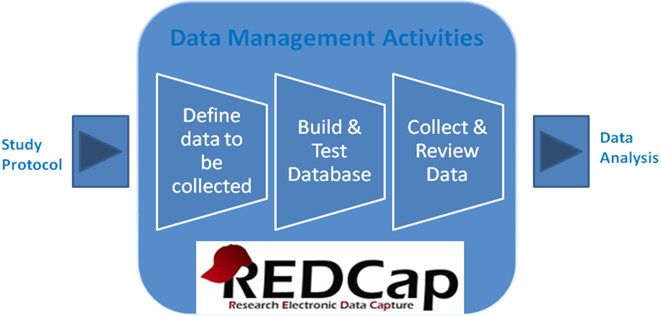

General Information

Access to REDCap
HSPH employees have access to REDCap using the same username/password as their HSPH login: https://redcap.sph.harvard.edu/redcap/. Access may be requested for non-HSPH employees by contacting sestime@hsph.harvard.edu who will provide instructions to onboard External Collaborators.
REDCap is a web-based application and can be used from anywhere, outside the HSPH network and from any encrypted mobile device (laptop, iPod, iPad).

Compliance
REDCap is designed with built-in features to address confidentiality and compliance requirements.
- Access control
Access is based on the Active Directory at HSPH only. External users who request access will be added to the HSPH Active Directory.
At the project level, access control is fully configurable: a project owner can authorize study staff access, as required per IRB protocol. Identifiers can be flagged and removed from data exports, depending on user profiles. See section 3.3.4 for more details on user rights.
- Audit trail
Every operation performed in REDCap is tracked and can be easily retrieved at the project level. (See logging feature in REDCap).
- Centralization of data on local servers
The REDCap application and data are both hosted on Partners secure servers. A backup is performed on a nightly basis.

Training
There is no formal training required to use REDCap but video tutorials and help text are available within each module in REDCap. Also, the ‘Help & FAQ’ tab in REDCap contains a lot of useful information.

Support
The REDCap application is developed and deployed by Vanderbilt University. At Partners, Enterprise Research Infrastructure & Services (ERIS) is responsible for the maintenance and the administration of the system. REDCap overview sessions and hands on labs are offered through ERIS. Contact edcsupport@partners.org for information on the next overview session.

How to use REDCap

Definition and wording
- Arms: group events into 'arms‘; there may be one or more arms/groups per project. Each arm can have as many events as needed.
- Branching logic: Branching Logic may be employed when fields/questions need to be hidden for data entry under certain conditions.
- Calendar: project calendar to help organize the patients’ scheduling and keep track of any upcoming events.
- CRF: Case Report Form.
- Data Dictionary: excel file, containing the list of fields of a given project and their associated attributes.
- Events: allow for the utilization of data collection forms multiple times for any given project record (often used when collecting longitudinal data). An 'event' may be a temporal event in the course of a project, such as a participant visit or a task to be performed.
- The terms field or variable or question may be used interchangeably and represent unique items of data to be collected and analyzed.
- File repository: repository that stores and retrieves files and documents used for a project. Whenever a data export is performed, the resulting data and syntax files are also stored in the file repository of the project.
- Instrument: survey page or data entry form.
- Logging: module that lists all changes made to this project, including data exports, data changes, and the creation or deletion of users (audit trail).
- Project status: development, production, draft, inactive and archived.
- Project type: single survey or data entry form(s) or a mix of a single survey / data entry form(s).
- Record Label: information/variables added to the unique ID of the study (e.g. pat_id) to help select the right record during data entry. For example, date of birth or last name can be added as record labels when selecting a subject for data entry. Record labels are displayed only and have no impact when exporting data.

Project workflow
Draft Protocol
Final Protocol

Inactive (optional) mode
View and analyze data
No data entry/update
Development mode
Build and test a project
Test data
Production mode
Enter, review and analyze data Real data

Protocol Amendment
Archived mode
Project is closed
Data analysis finalized

Draft mode
Update project setup
Data activities can continue during the update of the setup update

Build and test a project

Prerequisites
If collecting data for the purpose of human subject’s research, review and approval of the project by the Institutional Review Board is required. A data security level for the project will be assigned at the time of review. HSPH projects can only be hosted within REDCap if a security level 3 or below is assigned. REDCap users will need to contact sestime@hsph.harvard.edu to discuss level 3 assignments and ensure protections are in place.
 Define data to be collected before you start building a project.

The information that is going to be defined during this step will determine how to build the database.
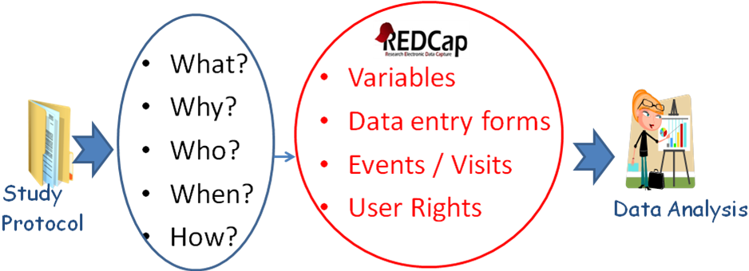
General recommendations:
- Protocol determines what data should be collected on the CRF
- Data that are not needed should not be collected: allow for efficient and complete data processing, analysis and reporting
- Avoid duplication: do not record the same information into multiple variables for the same event: e.g. DOB and age
- Provide instructions to reduce misinterpretations
- Be clear and concise with data questions
- Provide units to ensure comparable values
- Request minimal free text responses: provide pre-defined “choices”
- Use “None” and “Not done” to help tracking missing data
- Determine if data are collected once or multiple times during the project
- Determine if data are used across studies and organizations
- Determine how data will be collected: manual key entry, imported from Access or other source, imported from another study
- Determine who will enter data: Patients, Nurses, Study staff…

Build a project

Define a project type
There are three project types available in REDCap:
- Data collection performed only by study team Data entry forms
- Data collection performed only by subjects / study participants Survey
- Screening phase before enrolling subjects Survey + Data entry forms (Survey will be used to screen subjects and data entry forms to collect study data)
Note: the PI name and IRB# must be recorded in REDCap when creating a research project.
There are two collection formats available for data entry forms:
- Classic: one record per patient
- Longitudinal: one record per patient per event, with the possibility of defining multiple arms

Create instruments
When creating a ‘data entry forms’ project in REDCap, a demographics form is automatically added to the project. This form may be modified or deleted by the project owner.
A given field cannot be used in more than one instrument. The instruments are meant to organize data collection only; they have no impact on the structure of the database or on data extraction.
Create instruments and regroup the fields by instrument from a data collection logic standpoint:
- By modules: i.e. demographics, vitals, medication,
- By type of persons who collect data
- By data acquisition type: manual data entry or data import
- Regroup identifiers (PHI) on the same instrument to better protect subject’s data
- In a longitudinal study, fields that are entered at the same event or within the same arm are grouped together. Instruments may be used at multiple events/arms
Longitudinal study example:
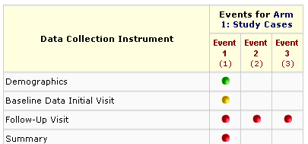

Data collection instruments may be also downloaded from the public Shared Library of instruments available within REDCap. If a public instrument is used in a given project, the content may not be modified.

Create fields
A field is defined by the following attributes: type, label, name, validation, required, identifier, note. In addition, a branching logic can be applied to specify whether or not a question will be displayed, depending on values entered in previous question(s).
Branching logic
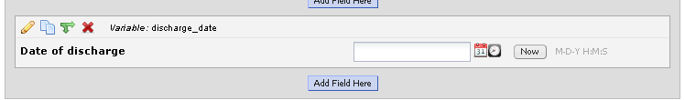

Field attributes
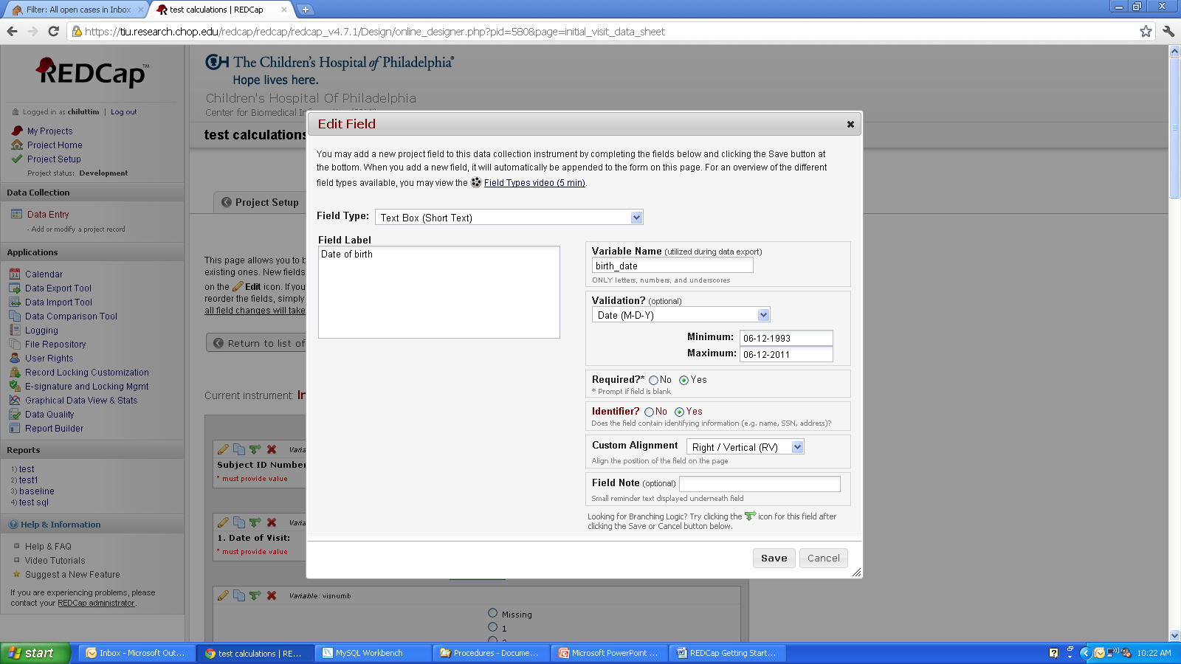
Name: will be column name in the export file for data analysis
Validation: to define data type and improve data quality: format will be checked during data entry & data import
Required?: a value will be required during data entry/data import
Label: will be displayed on the data entry form/survey, reports, PDFs
Identifier?: must be set to Yes for all PHI to be able to de-identify data exports and limit access to PHI within REDCap
Field Note: to guide data entry

Field names
- With some meaning to identify the content easily
  - Avoid using Q1, Q2, Q3
  - Use underscore if necessary
  - Do not use ‘$’ or ‘.’
  - Examples:
    - Use the word ‘date’ for all date fields
    - Use the word ‘time’ for all time fields
- MUST begin with a letter, otherwise data exports will not work when using SPSS
- Cannot end with a period
- Reserved keywords cannot be used as variable names (ALL, AND, BY, EQ, GE, GT, LE, LT, NE, NOT, OR, TO, and WITH)
- Should be kept short whenever possible (8 – 12 characters)
  - To avoid spelling errors during programming (analysis),
  - To display as column headers in reports and data exports
- Repeating measurements
  - Use the same name and add number
  - Example: weight1, weight2, weight3…

Available field types:

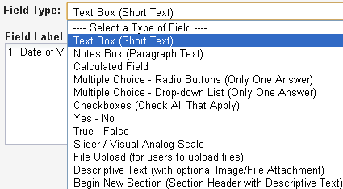
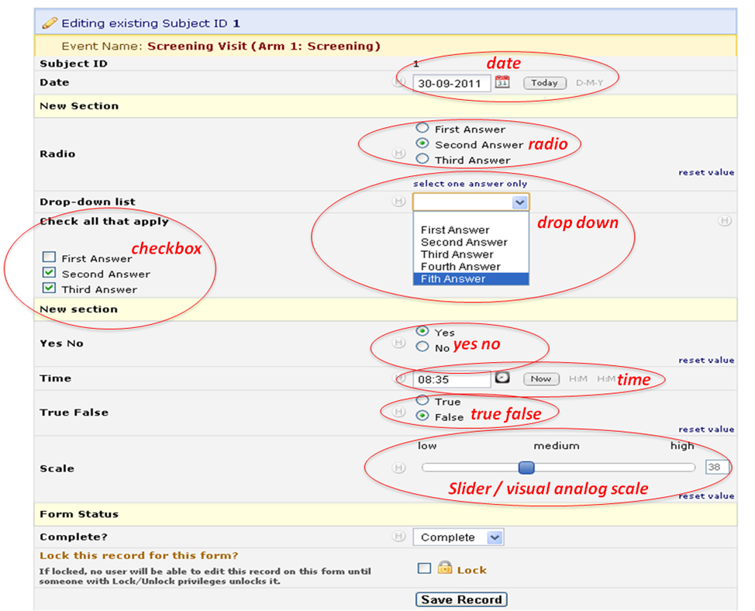
The collection of free text should be limited as it is difficult to analyze free text:
- Use categorical responses (drop-down, radio button or checkbox). REDCap will associate a number (code) with each answer (label). Consider using checkboxes to collect fields such as medications, symptoms and complications. REDCap will create a yes/no column in the dataset for each value that can be checked.
- Use pre-defined data type (text field with validation), i.e. yes/no, true/false, number, integer, date, datetime, time, zip code, email, phone.
Define range minimum / maximum whenever appropriate to allow REDCap to perform basic data validation / quality control.
All dates in a given study should be collected using the same format.
Limit the use of calculated fields in REDCap:
- Calculations are useful when the resulting value is used to take some action regarding the subject
- Other calculations should be done outside of REDCap.

Define user rights
The rights of each user who is granted access to a project must be defined individually, depending on the user’s profile. The table below lists the rights that are recommended per profile. A given person may have more than one profile. It is recommended to check all access rights on a regular basis during the study.
Profile  Function | Project Setup (access rights may be removed once the project is in production) | Data entry | Data review | Data Analysis
Calendar | x | x | x
Data Export | x |  | x | X
Data Import | x | X
Data Comparison (for double data entry) |  | x | x
Logging (audit trail) (to be limited) | x
File Repository | x | x | x | x
User Rights (to be limited) | x
Data Access Groups (to be used when multiple data entry sites) |  | x
Graphical Data View & Stats | x | x | x | x
Data Quality | x | x | x
Reports & Report Builder | x | X | X
Project Design & Setup | x
Record locking customization (if used) | x
Lock/Unlock Records (if used) |  | x | x
*Records (Create, Delete, Rename) (D to be limited) | C, D, R (for testing) | C | R, D
Data Entry Rights (none, read, edit) | Edit (for testing) | Edit | Read or Edit
Users who may not view PHI should have access only to:
- Calendar
- De-identified data export
- File repository
- Data Entry Rights section: The ‘None’ box must be checked for all forms that contain PHI. The ‘Data entry rights’ section determines the access to data when using the Calendar, building reports and viewing data with the Graphical Data View tool. Also, if access is given to some data entry forms, the record label (optional customization in REDCap) must not contain PHI.
- Data Quality
- Report Builder
- Graphical Data View & Stats
All other rights should be unchecked.

Test a project
The following tasks must be performed before moving a project into production!
- Enter test data using all fields in all instruments and all events to validate instruments and event definition, branching logic and calculated fields. Test data must include different cases that will allow testing all scenarios of branching logic, calculated fields and minimum/maximum ranges.
- Review test data: open data entry forms, create reports, export data and send the blank CRF to all co-investigators for review.
Have a statistician review your database (if applicable to your study):
  - Send the data dictionary of your database to the Statistician. This will clearly communicate any defined branching logic --- not communicated in the raw data file or meta-data formatting accessible through the "Data Export" application. This will also clearly communicate the formulas from calculated fields.
  - Send the blank CRF.
  - Have the Statistician perform a data export to ensure that they do not extract identifiers. They can give you feedback regarding the overall design of your database as well as the definition of each field. It is important to think through the planned statistical analysis before collecting any data. A statistician can make sure that you are collecting the fields you need, in the format you need them in, in order to perform the statistical analyses you need.

Move a project into production mode
Once all steps listed in the above sections are performed successfully, the project may be moved into production mode. Test data can and should be erased automatically when moving the project into production mode.

Enter, Review and analyze data

Enter data
- A unique key identifies every record: Study ID (aka Pat ID or Subject ID). This key identifier must be the first question on the first form (or survey) since REDCap uses this identifier as the key variable to link all forms/events for a particular subject uses it.
If multiple sites are involved in a study, it is recommended to use conventions in order to group subjects by site:
Example: 1 digit for the site and 3 digits for the subject number.
Site 1, subject 1: study Id = 1001
Site 2, subject 1: study Id = 2001
- Data can be key-entered into REDCap, using regular data entry via Data Entry Forms. Double data entry is an option available in REDCap. When this option is enabled, two data entry people will enter data, but instead of saving their data as normal, the Study ID (or unique record identifier) will have either a "--1" or "--2" appended to it, thus marking it as the record entered by data entry person 1 or 2. This is how the data entry people can enter data for the same subject/patient without having a duplicate record. Because all the records entered by the two users will end in the "--#" format, those users can only view the data that they themselves have entered. The "--#" format on the records are hidden from those two users, so to them everything appears as it normally would. However, Reviewers will be able to see the "--#" appended to the records when viewing them. When Reviewers choose to merge the two records entered by the data entry people, the new "third" record is saved without the "--#" appended to the end of the record name. The double data entry feature can be turn on by the REDCap Administrator only.
- Data can be imported into REDCap from a CSV file, using the data import tool. REDCap generates a template with all columns. Data must be copied into this template; columns may be removed but the first column must always be kept (e.g. study_id). During data import, data can be added or modified but cannot be deleted.

Review data
The data review should start at the beginning of data collection to detect any potential data entry errors and to update data entry instructions, if needed.
There are different tools available in REDCap to review data:
- Automatic checks during data entry or data import: REDCap will check automatically during data entry or data import for correct formatting of dates, times, numbers, ZIP codes, email addresses…and missing values for required fields.
- Data review tracking: each data entry form has a status that can be used to track the progress of data entry and/or data review: Incomplete, Unverified and Complete. In addition, the Lock/Unlock feature can be used to prevent accidental data modification or deletion. The e-signature is also an option that can serve as the equivalent of a handwritten signature.

Example of use:
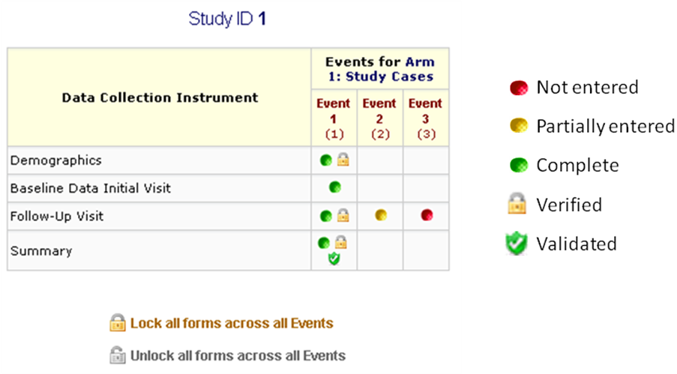
Note: the use of these tracking tools can be customized for each data entry form and project, depending on the needs of the project.
- Report Builder: will allow users to create, save, export and print customized data reports. Once a report is saved, all users who are granted access to the project and the Report Builder module of the project can see it. For example, a report can be created to check the chronological orders of dates across events.
- PDF: data for one or all records may be downloaded into a single PDF file.
- Contains the actual page format as seen on the data entry page or survey
- Includes all data or data from a single instrument
- May be used if data need to be shared within a short time period.
- Graphical data view and stats
This module can display any project data (numeric and coded data) in aggregate graphical format and as descriptive statistics. Example:
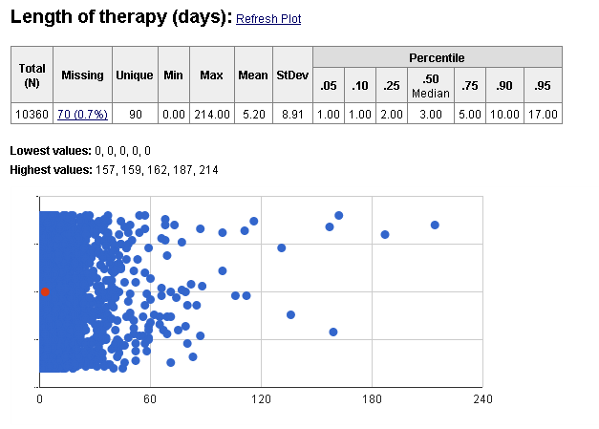
If clicking any of the points on the plot, the data entry form of that exact record will open.
- Data Exports: data can be exported in Excel
Data Exports in Excel format must be used as a tool for reviewing data and not as a data destination.
- Data Quality module
The aim of this module is to help quickly find discrepancies and errors in project data. This module contains rules that can be customized for the project; these rules can be executed at any time during the study. Users can exclude any results that they do not wish to see in future results.

When data review is finalized, the project may be moved into ‘inactive’ mode: can query/view data but cannot add/modify/delete data. The database is ready for statistical analysis.

Analyze data
The data export function will allow exporting data in various statistical formats, with the option to select all data or partial data. Formats available are: SPSS, SAS, R, STATA. The ‘Send-it’ function in REDCap can be used to send files that contain sensitive data. Send-It is a secure data transfer application that allows users to upload a file (up to 260 MB in size) and then allows multiple recipients to download the file in a secure manner. Each recipient will receive an email containing a unique download URL, along with a second follow-up email with the password for downloading the file (for greater security). The file will be stored securely and then later removed from the server after the specified expiration date. Send-It is the perfect solution for anyone wanting to send files that are too large for email attachments or that contain sensitive data.

De-identification methods for data exporting
REDCap provides advanced de-identification options that can be optionally used when exporting data, such as removing known Identifier fields, removing invalidated text fields, notes fields, or date fields, date shifting and hashing of the record names. These options provide greater security and data protection when a user is exporting sensitive data out of REDCap.
Date shifting: As part of the de-identification options in REDCap, all dates in the database may be shifted so that they do not reflect the actual dates. If the option to have all dates shifted is chosen, they will be shifted by a consistent length of time for each record, thus preserving the interval between dates. Date shifting leaves the database record intact and will not affect the actual saved dates in the database. The shifted dates will always be the same for each record when performing a data export. The dates are shifted back in time up to 364 days, in which the shifted value is based on the Study ID using a complex algorithm. Because the shifted value is based on the record name, the amount that dates are shifted is unique for each record, but the shifted amount remains the same within each record to maintain internal consistency. Date shifting prevents any dates from being used as identifiers for each database record while preserving the interval between dates.

Close a project
Once the data analysis is complete, the project in REDCap must be moved into ‘archive’ mode. This will take the project offline, and you and other users will no longer be able to access it normally. The project can be brought back online at any time after being archived by returning to this page in this project. It is good practice to remove all user rights from the project except for one user because if the project needs to be put back in production status, the access will be limited to one person.

We’d like to acknowledge Children’s Hospital of Philadelphia, Center for Biomedical Informatics for the original doc. template.

